Project Design Phase
Problem – Solution Fit Template

Date | 18 February 2026
Team ID | LTVIP2026TMIDS80016
Project Name | Flavor Fusion: AI- Driven Recipe Blogging
Maximum Marks | 2 Marks

Problem – Solution Fit Template:
Flavour Fusion targets food bloggers and home cooks facing writer’s block and ingredient indecision. The root cause is the lack of multimodal tools bridging inventory with inspiration. Users feel frustrated browsing Pinterest manually but become efficient through your Streamlit app. It leverages Gemini AI to generate SEO-friendly blogs, identify dishes from photos, and suggest recipes from random pantry items. While limited by session storage and API quotas, it solves manual drafting pains. This solution transforms online behavior from tedious searching to instant, AI-driven content creation and recipe discovery.

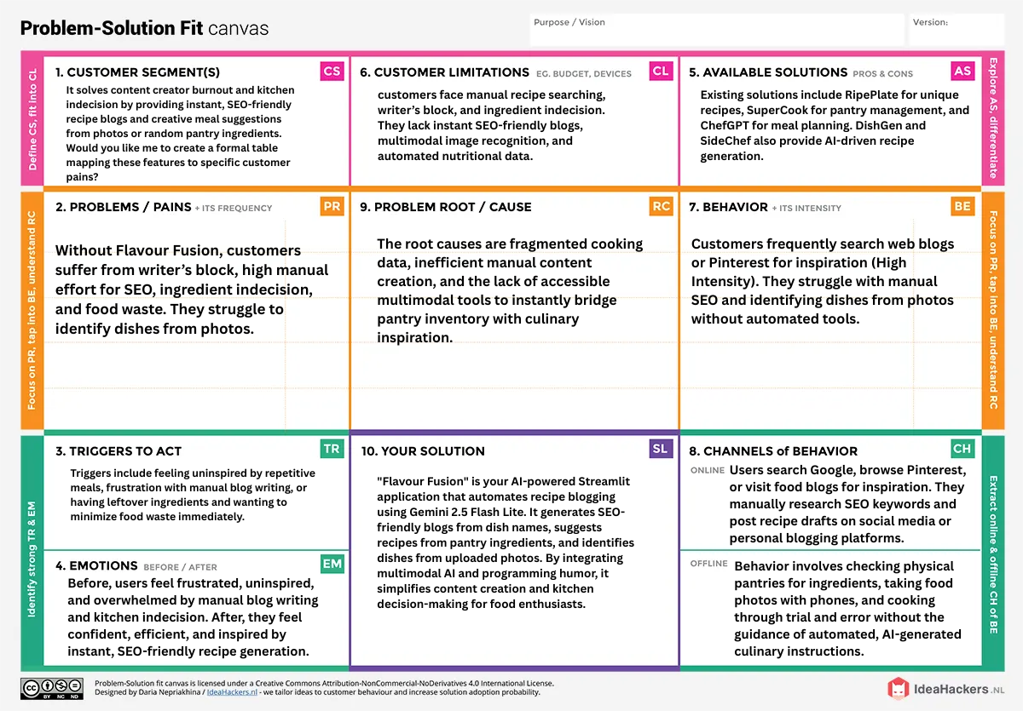

References:
- https://www.ideahackers.network/problem-solution-fit-canvas/
- https://medium.com/@epicantus/problem-solution-fit-canvas-aa3dd59cb4fe

